# **Name: Abdurrahman Qureshi**

# **Roll No: 210451**

Practical No: 19

**1)**

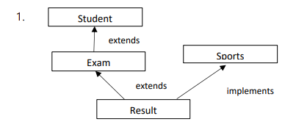

**CODE:**

import java.util.*;

import java.lang.*;

public class studInterface{

public static void main(String[] args) {

Result1 R = new Result1(51 ,"Ethan Winters", 85,87);

R.display();}}

class Student1{

protected String name;

protected int id;

Student1(int i,String n) {

id = i;

name = n; }

void display() {

System.out.println("\nUnique ID of Student \t: " + id);

System.out.println("Name of Student \t\t: "+ name); }}

class Exams extends Student1{

protected int m1;

protected int m2;

Exams(int i, String d,int mrk1 , int mrk2) {

super(i,d);

m1 = mrk1;

m2 = mrk2; }

void display() {

super.display();

System.out.println("Marks in Subject A \t\t: " + m1);

System.out.println("Marks in Subject B \t\t: " + m2); }}

interface Sports {

int mrk = 7; }

class Result1 extends Exams implements Sports{

protected int total = 0;

Result1( int i ,String n , int m , int b) {

super(i,n ,m,b);

total = m1 + m2; }

void display(){

super.display();

System.out.println("Total Marks \t\t\t: " + total); }}

**OUTPUT:**

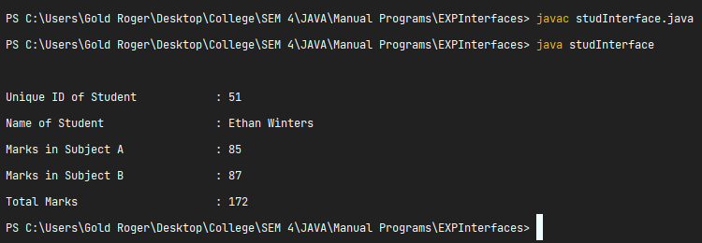

**2)**

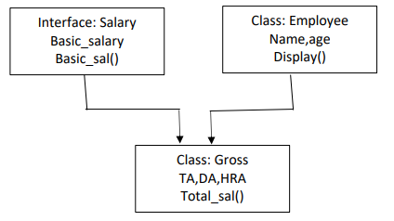

**CODE:**

import java.util.*;

import java.lang.*;

public class EmpInterface{

public static void main(String[] args) {

Gross R = new Gross(51 ,"John Wick");

R.display();}}

class Employee{

protected String name;

protected int id;

Employee(int i,String n) {

id = i;

name = n; }

void display() {

System.out.println("Age of Employee \t: " + id);

System.out.println("Name of Employee \t: "+ name); }}

interface Salary {

int basic_salary = 75000;

void basic_sal();}

class Gross extends Employee implements Salary{

protected int total = 0;

protected int da = 25000;

protected int ta = 10000;

protected int hra = 5000;

Gross( int i ,String n ) {

super(i,n);

total = basic_salary + hra + ta + da; }

public void basic_sal(){

System.out.println("\nBasic salary \t\t: " + basic_salary); }

void display(){

basic_sal();

super.display();

System.out.println("Gross Salary \t\t: " + total); }}

**OUTPUT:**

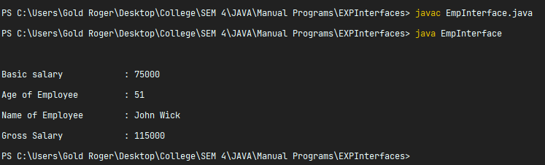

**3)**

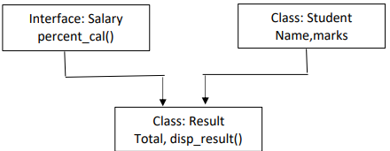

**CODE:**

import java.util.*;

import java.lang.*;

public class ExamInterface{

public static void main(String[] args) {

Result R = new Result(42,89,91,88 ,"SattarBaksh");

R.display_res();}}

class Student {

protected String name;

protected int id;

Student(int i,int j , int k , int l,String n) {

id = i; name = n; }

void display() {

System.out.println("Age of Student \t\t: " + id);

System.out.println("Name of Student \t: "+ name); }}

interface Exam {

// int basic_salary = 75000;

public void percent_cal(int i , int j, int k, int l); }

class Result extends Student implements Exam{

protected int total = 0;

protected int p = 0;

Result( int i ,int j , int k , int l,String n ) {

super(i,j,k,l,n);

percent_cal(i,j,k,l);

total = i+j+k+l; }

public void percent_cal(int i , int j , int k ,int l) {

double p = (float)(i+j+k+l)/400*100;

System.out.println("Perecentage \t\t: " + p); }

void display_res() {

super.display();

System.out.println("Total Marks \t\t: " + total); }}

**OUTPUT:**

